Quiz Import Guide
Contents
Updating Course Quizzes 2
Importing the Question Bank Update 3
Updating the Question Banks and Quizzes 5
Saving the Quiz 10

Importing Course Quizzes (for Bridging Materials)

This guide is intended to outline the steps needed to import Quizzes into a course and to make them available in your NetSpace course.

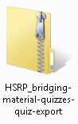
Importing the Question Bank Update

  - Step 1. Download the Quiz Export File from Instructor Resources

- Log into NetSpace.
- Go to Community Support Forum CCNA R&S Offering CCNA Routing and Switching Bridging Materials
- Click on the Quiz link. (The file will download.)
- Save the file.

  - Step 2. Import the Quiz

- Open the Course.
- Click the Settings link.
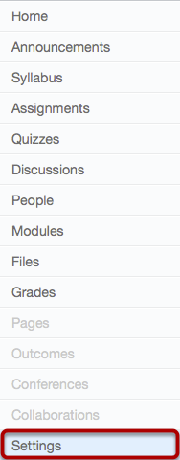

- Click the Import Content into this Course button.

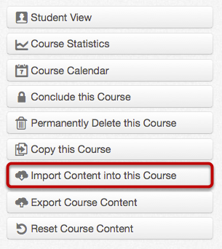

- Select Canvas Course Export Package from the Content Type dropdown.

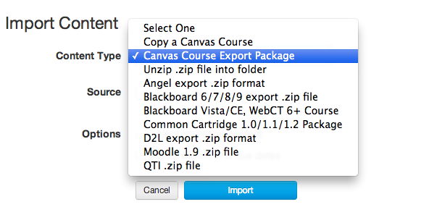

- Browse for the Quiz zip file.
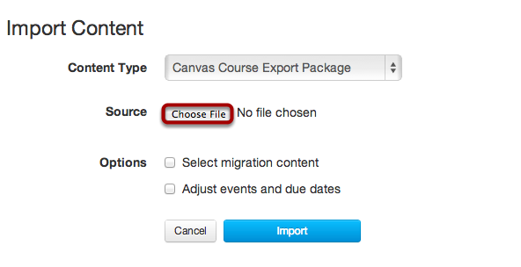
  - Click the Choose File button.
  - Locate the Quiz package to import on your computer and click Open.
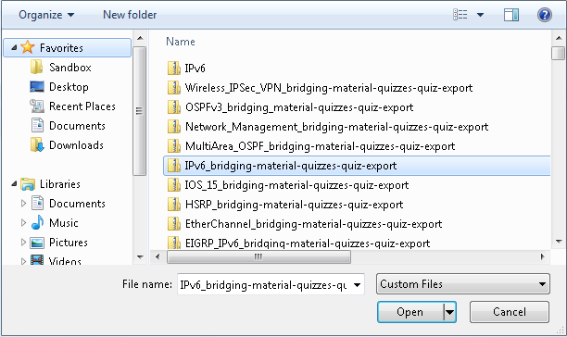

- Click Import.

- Course Completion
The Current Jobs menu will display the status of your import. Running reports will display a menu bar with the time remaining to generate the report.
You will also receive an email notification when your import is completed.

- Select Quizzes on the left Navigation Bar. The imported quiz will be listed under the Unpublished Quizzes section.

Note: When the quiz imports, it does not import any of the Quiz Settings (including the Quiz description). The values must be set by the instructor.
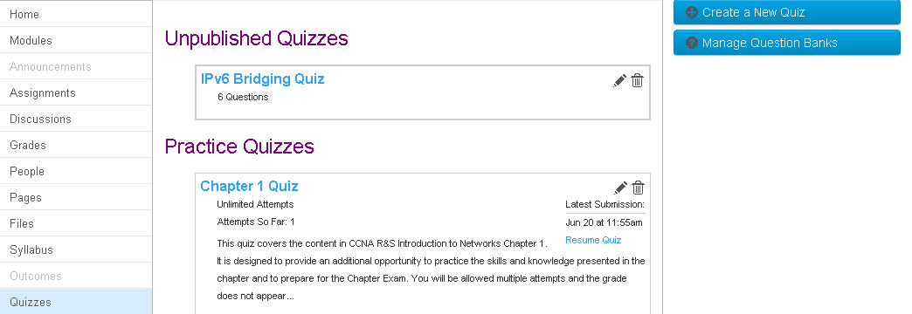
- Click the Quiz title to edit the quiz.
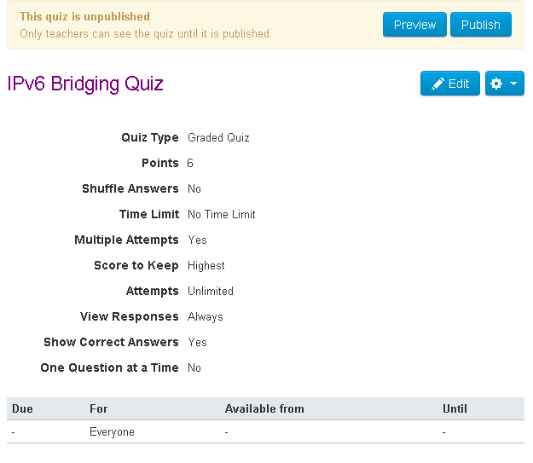

- Change Quiz Settings. There may be some quiz attributes that you may want to change before publishing the quiz. These are optional settings.
- Click Save retain your changes.

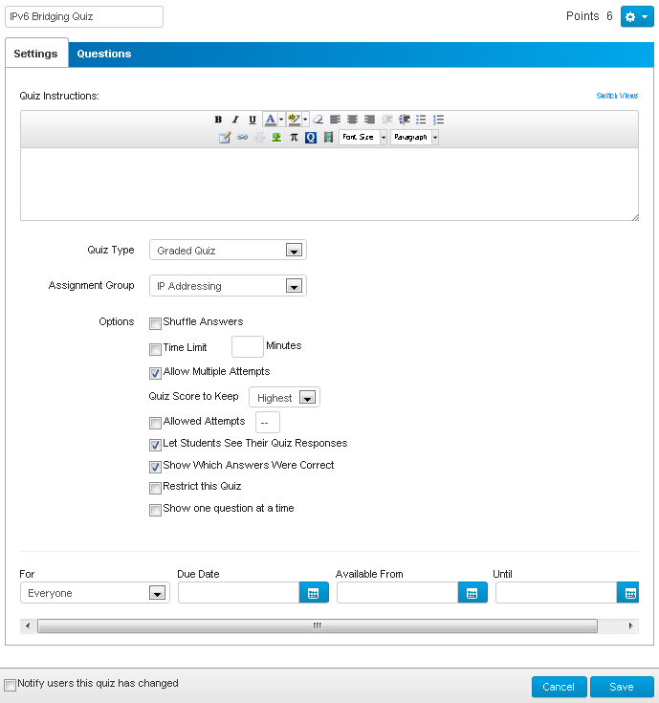

- Publish the quiz. It is not available for the students to take.

